Name: Dr. Chongtham Sovachandra Singh
Curriculum Vitae
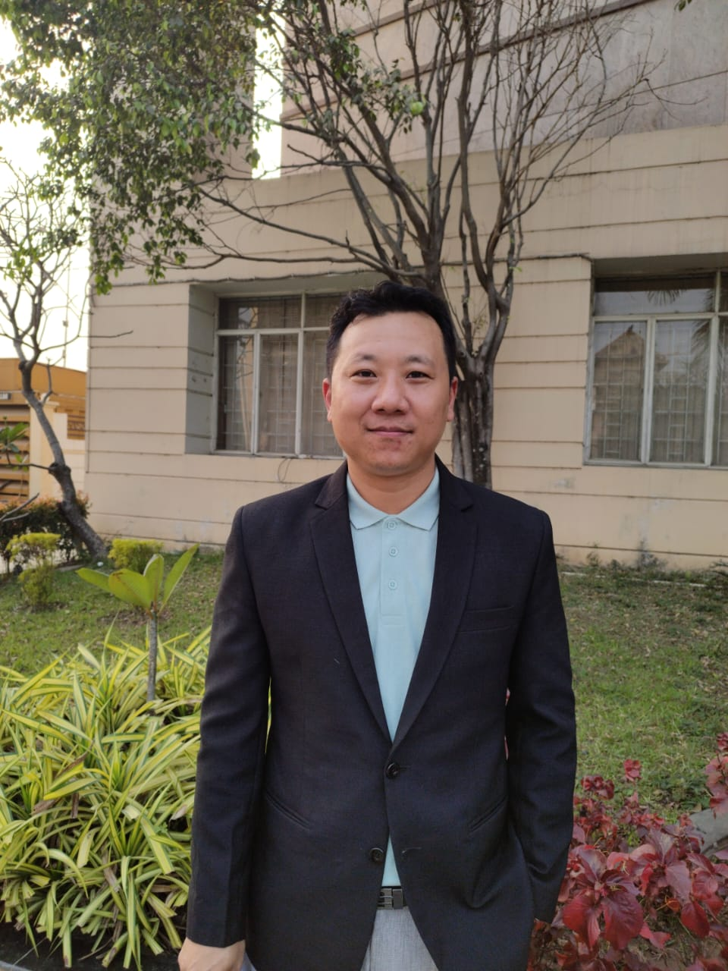
Date of Birth: August 3, 1988
Gender: Male
Nationality: Indian
Passport Number: V5091255
Permanent Address: Nongchup Kameng Mamang Leikai,
P.O./P.S. Lamsang,
Imphal West – 795146, Manipur.
Correspondence Address:
Dept. of Biochemistry
The Assam Royal Global University
Betkuchi – 781035.
Contact Number: (+91) 9856068334
E-mail ID: cssingh@rgu.ac

Qualification:
- B.Sc. Botany (Honors), 2010, 1st Class 1st Position Gold Medalist, Manipur University
- M.Sc. Biotechnology & Bioinformatics, 2012, 1st Class, North-Eastern Hill University, Shillong
- Ph.D. in Biotechnology & Bioinformatics, 2021, North-Eastern Hill University, Shillong

Fellowship
- CSIR UGC NET JRF 2011 with AIR 61.
- CSIR UGC NET JRF 2015 with AIR 96.
- UGC NET LS 2014 with AIR 41.
- DBT JRF 2014

Research Interest
Here at the Assam Royal Global University, we have formed a research team focused on molecular and cancer biology involving several key steps to ensure successful collaboration and productive research outcomes. My research interests lie at the intersection of molecular biology, genetics, and cancer biology. I am fascinated by the intricate molecular mechanisms underlying cellular processes, genetic variations, and their implications for cancer development and progression. Through my academic and research experiences, I have developed a keen interest in investigating the molecular basis of cancer, with a focus on understanding the genetic alterations and molecular pathways involved in tumor initiation, growth, and metastasis.
One aspect of my research interest is in exploring the genetic and epigenetic alterations that contribute to the development of various types of cancer. I am particularly interested in identifying and characterizing key driver mutations, oncogenes, and tumor suppressor genes that play critical roles in tumorigenesis. Understanding the functional consequences of these genetic alterations and their impact on key signaling pathways can provide valuable insights into the underlying molecular mechanisms of cancer formation.
In addition to genetic alterations, I am intrigued by the role of epigenetic modifications in cancer biology. Epigenetic changes, such as DNA methylation, histone modifications, and non-coding RNA molecules, can significantly influence gene expression patterns and cellular phenotypes. Investigating the epigenetic landscape of cancer cells and deciphering the regulatory networks involved in epigenetic modifications are essential for unraveling the complexity of cancer development and identifying potential therapeutic targets.
Overall, my research interests encompass molecular biology, genetics, and cancer biology. By investigating the molecular mechanisms underlying cancer development, and progression, I aim to contribute to the understanding of cancer biology and identify novel therapeutic strategies for improved cancer management and patient care.

Experience
- Research Experience: 6 years of research experience as a Ph.D. Scholar and a Project fellow.
- Teaching Experience: 0.5 years of Teaching experience in Royal Global University.

Publications
- Pallavi Yadav, Atanu Banerjee, Nabamita Boruah, Chongtham Sovachandra Singh, et al. Glutathione S-transferasesP1 AA (105Ile) allele increases oral cancer risk, interacts strongly with c-Jun Kinase, and weakly detoxifies areca-nut metabolites. Scientific Reports 10: 6032 (2020).
- Debabrata Tripathy, Ravi Upadhayay, Chongtham Sovachandra Singh, Nabamita Baruah, Nripendra Mandal, Anupam Chatterjee, Mitigation of X-ray induced DNA damages and expression of DNA-repair genes by antioxidative Potentilla fulgens root extract and its ethyl-acetate fraction in mammalian cells. Mutagenesis 36: 165-175 (2021).
- Nabamita Boruah, Chongtham Sovachandra Singh, Pooja Swargiary, Hughbert Dakhar, Anupam Chatterjee. Securin overexpression correlates with the activated Rb/E2F1 pathway and Histone H3 epigenetic modifications in raw areca-nut-induce carcinogenesis in mice. Cancer Cell International 22:30 (2022).
- Chongtham Sovachandra Singh, Atanu Banerjee, Nabamita Boruah, Pooja Swargiary, Henry B Nongrum, Suvamoy Chakraborty, Anupam Chatterjee. The emerging potential of securing upregulation, premature anaphase separation: sister chromatid exchanges as intermediate end-points to monitor oral and esophageal carcinogenesis. Biomarkers Journal 8(1): 109 (2022).
- Pooja Swargiary, Nabamita Boruah, Chongtham Sovachandra Singh, Anupam Chatterjee. Genome-wide analysis of DNaseI hypersensitivity unveils open chromatin associated with histone H3 modifications after areca nut with lime exposures. Mutagenesis 37(3-4): 182-190 (2022).

Book Chapters Published: None
Extramurally funded projects awarded: None

